Interior Border Gateway Protocol Lab

Joshua Widjaja

P0-2 Cisco CCNP

Mr. Mason

**Purpose:**

The sole purpose of this lab was to become even more familiar with using Border Gateway Protocol (BGP) and specifically its two types of BGP peering, internal Border Gateway Protocol (iBGP) and external Border Gateway Protocol (eBGP). BGP plays a vital role in making sure routing between different Autonomous Systems (AS) is efficient and reliable. By learning about the two variants of BGP, we can dive deeper into seeing how the Routing information is passed between autonomous systems in a network. iBGP is used for exchanging routing information internally within a single autonomous system. eBGP on the other hand is needed for exchanging routing information between routers in different autonomous systems. Apart from BGP, another routing protocol that we used in this lab was Open Shortest Path First (OSPF). We needed to use OSPF to help exchange routing information internally between routers in a single autonomous system.

**Background Information:**

**Border Gateway Protocol** focuses on the exchanging of routing information for external networks. An Autonomous System (AS) is a group of networks or a large network with a single routing policy.

**iBGP** is an interior gateway routing protocol used to exchange routing information between routers within the same Autonomous System. It is used to make sure that all routers in the single autonomous system know each other’s routes and can make reliable decisions based on the best way to route traffic internally. All internal routers have the same view of the full network topology, including BGP information. In this way, iBGP ensures that routers within the autonomous system have reliable routing information, creating efficient packet forwarding and network reachability. IBGP uses IGP path to reach an IBGP peer for connection.

**eBGP** is an exterior gateway routing protocol used to exchange routing information between different autonomous systems. External BGP is the most extensively used exterior routing protocol and is crucial for the efficiency of delivering packets from one autonomous system to the next. Through eBGP, neighbors do not have to be directly connected to each other. EBGP sends uses an AS_PATH attribute for loop prevention. EBGP uses a hop-by-hop strategy for path selection.

The glaring difference between eBGP and iBGP is that external BGP doesn’t require a full mesh of routers, whereas internal BPG does. In a full mesh network, each router is connected directly to each of the other routers. As the number of routers in the network increases, maintaining a full-mesh configuration becomes increasingly complex and requires more resources to manage and scale. Full mesh iBGP networks also possess the vulnerability to human error in the complexity of the configurations. Thus, the biggest advantage of using eBGP is its scalability, unlike iBGP. External BGP can take on large amounts of data and route it efficiently without interruption, making it favorable for applications requiring higher levels of passing routing information. EBGP enables automatic route advertisement from one autonomous system to another, creating more efficient exchanging of routing information and greater scalability. Using eBGP, organizations can configure a larger network needing less resources.

**Lab Summary:**

We first set up our network topology with its IP scheme. We implemented three unique autonomous systems, each having different AS numbers. Our two edge routers had their own autonomous system and were configured with eBGP. We also put a loopback connection which connected to the end of each edge router. Having a loopback connection was helpful in testing the network locally without using an external network connection. In the middle of our network topology, we put in an autonomous system for three iBGP routers. For our configured iBGP routers we used another routing protocol called OSPF to ensure local connection. To receive our IPv4 routes we entered network, neighbor, redistribute, and BGP commands.

**Lab Commands:**

The important command that I learned was “**redistribute ospf [*process_id*] match external 2**.” This command is used to redistribute external routes into BGP. The command must be entered under **router bgp [AS_number]**. The external part of the command specifies which OSPF routes to redistribute. Entering **internal 1** would redistribute OSPF internal routes and **external 2** redistributes OSPF external type 2 routes. We used external type 2 because we needed to redistribute routes into OSPF from another routing protocol.

After configuring iBGP and eBGP using the commands **show ip bgp summary, show ip bgp neighbors,** and **show ip bgp** was helpful in verifying ip addresses of BGP neighbors and the assigned autonomous system numbers to each BGP neighbor.

**Network Diagram:**

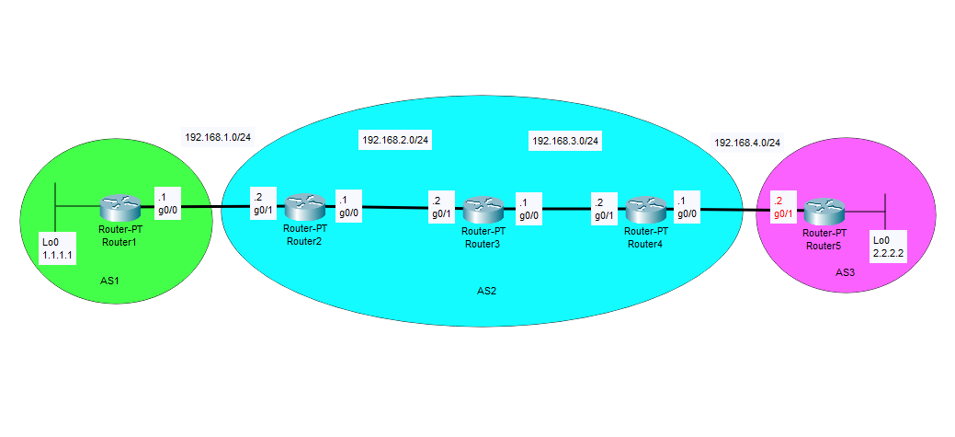

**Configurations:**

**---R1---**

R1#show run  
Building configuration...

Current configuration : 1605 bytes  
  
Last configuration change at 17:13:17 UTC Wed Mar 6 2024  
  
version 16.9  
service timestamps debug datetime msec  
service timestamps log datetime msec  
platform qfp utilization monitor load 80  
no platform punt-keepalive disable-kernel-core  
  
hostname R1  
  
boot-start-marker  
boot-end-marker  
  
vrf definition Mgmt-intf  
  
address-family ipv4  
exit-address-family  
  
address-family ipv6  
exit-address-family  
  
no aaa new-model  
  
login on-success log  
subscriber templating  
  
vtp domain cisco  
vtp mode transparent  
multilink bundle-name authenticated  
  
license udi pid ISR4321/K9 sn FDO21482HZX  
license boot level appxk9  
no license smart enable  
diagnostic bootup level minimal  
  
spanning-tree extend system-id  
  
redundancy  
mode none  
  
interface Loopback0  
ip address 1.1.1.1 255.255.255.255  
  
interface GigabitEthernet0/0/0  
ip address 192.168.1.1 255.255.255.0  
negotiation auto  
  
interface GigabitEthernet0/0/1  
no ip address  
negotiation auto  
  
interface Serial0/1/0  
no ip address  
shutdown  
  
interface Serial0/1/1  
no ip address  
shutdown

interface GigabitEthernet0  
vrf forwarding Mgmt-intf  
no ip address  
shutdown  
negotiation auto  
  
router bgp 1  
bgp log-neighbor-changes  
network 1.1.1.1 mask 255.255.255.255  
redistribute connected  
neighbor 192.168.1.2 remote-as 2  
  
ip forward-protocol nd  
no ip http server  
no ip http secure-server  
ip tftp source-interface GigabitEthernet0  
  
control-plane  
  
line con 0  
transport input none  
stopbits 1  
line aux 0  
stopbits 1  
line vty 0 4  
login  
  
end

**---R2---**

R2#show run  
 Building configuration...

Current configuration : 4111 bytes  
  
 Last configuration change at 17:02:38 UTC Wed Mar 6 2024  
   
 version 16.9  
 service timestamps debug datetime msec  
 service timestamps log datetime msec  
 platform qfp utilization monitor load 80  
 platform punt-keepalive disable-kernel-core  
   
 hostname R2  
   
 boot-start-marker  
 boot-end-marker  
  
 vrf definition Mgmt-intf  
   
 address-family ipv4  
 exit-address-family  
   
 address-family ipv6  
 exit-address-family  
  
  
 no aaa new-model  
  
 login on-success log  
   
 subscriber templating  
   
 vtp domain cisco  
 vtp mode transparent  
 multilink bundle-name authenticated  
  
 crypto pki trustpoint TP-self-signed-2105456491  
 enrollment selfsigned  
 subject-name cn=IOS-Self-Signed-Certificate-2105456491  
 revocation-check none  
 rsakeypair TP-self-signed-2105456491  
  
 crypto pki certificate chain TP-self-signed-2105456491  
 certificate self-signed 01  
 30820330 30820218 A0030201 02020101 300D0609 2A864886 F70D0101 05050030  
 31312F30 2D060355 04031326 494F532D 53656C66 2D536967 6E65642D 43657274  
 69666963 6174652D 32313035 34353634 3931301E 170D3233 30363036 31383232  
 32395A17 0D333030 31303130 30303030 305A3031 312F302D 06035504 03132649  
 4F532D53 656C662D 5369676E 65642D43 65727469 66696361 74652D32 31303534  
 35363439 31308201 22300D06 092A8648 86F70D01 01010500 0382010F 00308201  
 0A028201 0100876A 184F35C6 0E929121 EE3811A8 28E1A40F FD6DDB23 539E0D71  
 8E7E6090 3554D474 46DF5C06 8E68CDAC B1FF1F90 ACF8D30E 20CD2F18 A3D2A9D8  
 AC5627B9 D2163758 C17AEB01 07A8C0CF 3C9C8CF9 ED7074F9 02991FB8 1E7409DD  
 74AEB5A2 40DC020A 5DE53722 7FFD0381 BD09A39C 11C123E4 BE55D472 1607DBD8  
 987513C4 03E13D0D B539E73B 7DF22B0C 7C34FEC8 89133906 8F3BB98B 6D8AD20E  
 0A490E56 48B00F73 80D3F9E9 A8B16B4D 64A6C0B4 C5C65E75 8FEAF49C 2B49687F  
 B150A1EC 6873780E 1AADEF00 CE9F01A6 17C6382D 4D71B2E6 1E4C78DA 5A46E715  
 3EE04254 0DC6B096 180F1EF5 FC4BE073 C1B9221D 3A4C9F87 C15B7860 0EF18D3E  
 54B842D5 0ABD0203 010001A3 53305130 0F060355 1D130101 FF040530 030101FF  
 301F0603 551D2304 18301680 1440DDFF E73B2EAD ED3921BA A11AEE2E 6D45A59B  
 59301D06 03551D0E 04160414 40DDFFE7 3B2EADED 3921BAA1 1AEE2E6D 45A59B59  
 300D0609 2A864886 F70D0101 05050003 82010100 5B8F2495 D377BC11 0B345122  
 96F7CB9A 8003892D F80D3933 C744DFE8 D0C85690 A020EF0C D378F115 D2DFFBD5  
 7A915909 82581749 596387CB B7E832DF CBD3E80B 9C03DB26 DA183114 57E74C7D  
 27386F78 F616A79F 984C1F31 CEEBFC5A A7899161 15D25D18 0E3E64C0 1451C28A  
 E591F4F3 121F95BC E482E801 2886D58F 4B704519 75E997BC 751FCFA9 8C0FD4B5  
 707B872B BAAE459F A94760DE 290E7468 C566D6E4 C2E9AB64 DCD64D7E E4C533E1  
 02C26C97 342238B1 985B5E18 A43B10B3 69E0A5ED 30796592 C66037AE DAFA667A  
 782B7257 3E033740 86EB13DD 6D60C50E C84D2F03 0CF888C6 D1356561 7DB99621  
 79DC8347 077D1D63 E20BC2A1 AF6EC6E2 81F3D397  
 quit  
  
 license udi pid ISR4321/K9 sn FDO21482DWJ  
 license boot level appxk9  
 no license smart enable  
 diagnostic bootup level minimal  
 spanning-tree extend system-id  
  
 redundancy  
 mode none  
  
 interface GigabitEthernet0/0/0  
 ip address 192.168.2.1 255.255.255.0  
 ip ospf 1 area 0  
 negotiation auto  
   
 interface GigabitEthernet0/0/1  
 ip address 192.168.1.2 255.255.255.0  
 negotiation auto  
   
 interface Serial0/1/0  
 no ip address  
 shutdown  
   
 interface Serial0/1/1  
 no ip address  
 shutdown  
   
 interface GigabitEthernet0  
 vrf forwarding Mgmt-intf  
 no ip address  
 shutdown  
 negotiation auto  
   
 router ospf 1  
 redistribute connected subnets  
 redistribute bgp 2 subnets  
 network 192.168.2.0 0.0.0.255 area 0  
 network 192.168.3.0 0.0.0.255 area 0  
   
 router bgp 2  
 bgp log-neighbor-changes  
 redistribute connected metric 5  
 redistribute ospf 1 metric 1 match internal external 2  
 neighbor 1.1.1.1 remote-as 1  
 neighbor 192.168.1.1 remote-as 1  
 neighbor 192.168.2.2 remote-as 2  
 neighbor 192.168.2.2 update-source GigabitEthernet0/0/0  
   
 ip forward-protocol nd  
 ip http server  
 ip http authentication local  
 ip http secure-server  
 ip tftp source-interface GigabitEthernet0  
   
 control-plane  
   
 line con 0  
 transport input none  
 stopbits 1  
 line aux 0  
 stopbits 1  
 line vty 0 4  
 login  
   
 end

**---R3---**

R3#show run  
Building configuration...

Current configuration : 4040 bytes  
Last configuration change at 16:53:55 UTC Wed Mar 6 2024  
  
version 16.9  
service timestamps debug datetime msec  
service timestamps log datetime msec  
platform qfp utilization monitor load 80  
platform punt-keepalive disable-kernel-core  
  
hostname R3  
  
boot-start-marker  
boot-end-marker  
  
vrf definition Mgmt-intf  
  
address-family ipv4  
exit-address-family  
  
address-family ipv6  
exit-address-family  
  
no aaa new-model  
  
login on-success log  
  
subscriber templating  
  
vtp domain cisco  
vtp mode transparent  
multilink bundle-name authenticated  
  
crypto pki trustpoint TP-self-signed-2949602955  
enrollment selfsigned  
subject-name cn=IOS-Self-Signed-Certificate-2949602955  
revocation-check none  
rsakeypair TP-self-signed-2949602955  
  
crypto pki certificate chain TP-self-signed-2949602955  
certificate self-signed 01  
  30820330 30820218 A0030201 02020101 300D0609 2A864886 F70D0101 05050030  
  31312F30 2D060355 04031326 494F532D 53656C66 2D536967 6E65642D 43657274  
  69666963 6174652D 32393439 36303239 3535301E 170D3233 30363036 31383138  
  33395A17 0D333030 31303130 30303030 305A3031 312F302D 06035504 03132649  
  4F532D53 656C662D 5369676E 65642D43 65727469 66696361 74652D32 39343936  
  30323935 35308201 22300D06 092A8648 86F70D01 01010500 0382010F 00308201  
  0A028201 0100C6B5 B6C310C4 166068B7 15C74E3E 53F7C254 939DBD5B E2434EC9  
  4FCA1119 86013DAA 104B9104 7AE81A7D 62DDA0AE 836E3586 DFDD1E84 5C287973  
  3328DD4D F48BF6D2 52662405 1841E05F B2FF3EC1 CC6A3955 064D5490 C240DEEF  
  3948256A 5BC47454 92A048CD DA5FCAD8 1D745E89 870637FB C36CFC5E 45760A8D  
  0E1BD89A 7EE17E9E 5EAE4702 46DDBF57 6C4D7E5F 2CA008E7 E7E6F775 74DAF7EF  
  D04D09A2 5B427C52 4AB66E61 38508337 E3BCF313 0A40F195 F368478D A335A20B  
  BB701646 D317E6D4 AE6A859F 5AE791B7 8EFC6926 0C73BA7D 7CB96288 7ECF7E1B  
  4B41CCBE 0F56B91F ACBCED21 A0B621ED 5D64DC14 60E2A166 C0245203 A43E7CF8  
  CDB7AE05 368D0203 010001A3 53305130 0F060355 1D130101 FF040530 030101FF  
  301F0603 551D2304 18301680 149E38E7 4A07C2C4 CBC2185B 51B7256D F324FDDC  
  99301D06 03551D0E 04160414 9E38E74A 07C2C4CB C2185B51 B7256DF3 24FDDC99  
  300D0609 2A864886 F70D0101 05050003 82010100 221DD907 7E6116E7 361E4334  
  65D7ED95 6D1BB560 18432F68 9A4E4892 8BF9CD6F 2F1913AE 9B714EDA 2F37A0F0  
  531230DE 107289B1 628BB27F 3DC2CB84 D5E98C24 AB0D0D96 C8AEE293 3DEA769F  
  6DCA8267 1E50F272 EDDADF26 AC33371C B79A996A 83B6F7F7 DBF7FAEA D1B71FA3  
  07A5319B C545D7E5 7BC1C54F 1AC38B70 1AE6A10A 94A6F479 913EDB2C 971832C2  
  624DE6A7 3539E597 89CFAAAB 8B91A963 8B7A37FD 64EABCE8 C9A9AE43 92C3C0FF  
  86C8894E 21B2743D 07522338 EE69AE4A FD968EE7 A8FB88BF 42858824 86583368  
  C267EDAE 753390AB 5EFD923F 925102BF 9CCA72C1 2BA44FE4 8918CB12 B9D8A1FC  
  F2B9E102 5E585CE2 F980BAC1 D9C5AD01 338D1CB9  
        quit  
  
license udi pid ISR4321/K9 sn FDO214420HW  
license boot level appxk9  
no license smart enable  
diagnostic bootup level minimal  
  
spanning-tree extend system-id  
  
redundancy  
mode none  
  
interface GigabitEthernet0/0/0  
ip address 192.168.3.1 255.255.255.0  
ip ospf 1 area 0  
negotiation auto  
  
interface GigabitEthernet0/0/1  
ip address 192.168.2.2 255.255.255.0  
ip ospf 1 area 0  
negotiation auto  
  
interface Serial0/1/0  
no ip address  
shutdown  
  
interface Serial0/1/1  
no ip address  
shutdown  
  
interface GigabitEthernet0  
vrf forwarding Mgmt-intf  
no ip address  
shutdown  
negotiation auto  
  
router ospf 1  
redistribute connected subnets  
redistribute bgp 2 subnets  
network 192.168.2.0 0.0.0.255 area 0  
network 192.168.3.0 0.0.0.255 area 0  
  
router bgp 2  
bgp log-neighbor-changes  
network 192.168.2.0  
network 192.168.3.0  
redistribute connected  
redistribute ospf 1  
neighbor 192.168.2.1 remote-as 2  
neighbor 192.168.3.2 remote-as 2  
  
ip forward-protocol nd  
ip http server  
ip http authentication local  
ip http secure-server  
ip tftp source-interface GigabitEthernet0  
  
control-plane  
  
line con 0  
transport input none  
stopbits 1  
line aux 0  
stopbits 1  
line vty 0 4  
login  
  
end

**---R4---**

R4#show run  
Building configuration...

Current configuration : 4034 bytes  
Last configuration change at 16:56:18 UTC Wed Mar 6 2024  
  
version 16.9  
service timestamps debug datetime msec  
service timestamps log datetime msec  
platform qfp utilization monitor load 80  
platform punt-keepalive disable-kernel-core  
  
hostname R4  
  
boot-start-marker  
boot-end-marker  
  
vrf definition Mgmt-intf  
  
address-family ipv4  
exit-address-family  
  
address-family ipv6  
exit-address-family  
  
no aaa new-model  
  
login on-success log  
  
subscriber templating  
vtp domain cisco  
vtp mode transparent  
multilink bundle-name authenticated  
  
crypto pki trustpoint TP-self-signed-262078645  
enrollment selfsigned  
subject-name cn=IOS-Self-Signed-Certificate-262078645  
revocation-check none  
rsakeypair TP-self-signed-262078645  
  
crypto pki certificate chain TP-self-signed-262078645  
certificate self-signed 01  
  3082032E 30820216 A0030201 02020101 300D0609 2A864886 F70D0101 05050030  
  30312E30 2C060355 04031325 494F532D 53656C66 2D536967 6E65642D 43657274  
  69666963 6174652D 32363230 37383634 35301E17 0D323430 33303532 30313832  
  315A170D 33303031 30313030 30303030 5A303031 2E302C06 03550403 1325494F  
  532D5365 6C662D53 69676E65 642D4365 72746966 69636174 652D3236 32303738  
  36343530 82012230 0D06092A 864886F7 0D010101 05000382 010F0030 82010A02  
  82010100 C29A74C3 80C09314 8D07BA4B 56190E37 E9A3260D 0F2E2160 3659DEA3  
  BE9B3F40 F613BB2E B07602F8 988A3FED 7E922DA6 4A4F11A9 881811CD BAFF5209  
  A05F36D8 2006CC03 A661B6D5 E0C128F4 3BBA86E9 490154C1 0CE40A9A 81367803  
  F4DAC229 72E6E2F4 984BAFA7 EDA80D8F 956F404C 04A0E07E DD3B9DB1 1A057074  
  0F3ACDB2 2E495C5D 6D202D13 50F88C58 EF98CEA9 927ACAD6 F8F64D1C 30AB9071  
  99AF6A32 3C3A9C22 587B0B07 BEE0C522 D2B230E3 0BC38B40 CBEB34F4 F90EB196  
  B61B4482 630B849D 58A7C5E2 4098C538 2104D0EB 4AA1A7FE 07437996 656CBFC0  
  56B88EB5 0B972264 F5AAD856 3E1C9A0D 5BB6BA99 B7F03AE8 A166C574 0287B7A0  
  657CD357 02030100 01A35330 51300F06 03551D13 0101FF04 05300301 01FF301F  
  0603551D 23041830 168014CE DFC7931D C49FC463 530BD592 6AF7706C 0735F330  
  1D060355 1D0E0416 0414CEDF C7931DC4 9FC46353 0BD5926A F7706C07 35F3300D  
  06092A86 4886F70D 01010505 00038201 0100518E E0C5031F 1610B759 4E95268B  
  E1E6941B 80F0EC53 FBDD05AE 9CECEBEE E6699549 D6BD2EEB BC23D5DB 94FB225D  
  BA702CD8 67FE9BA7 B716175A BDD5870A B1F568AE 87ADF88B 59BF3D0A 44564502  
  48299A86 36849BEB EC1EBDDE A1A8AA31 63F645ED A1B1C0BE 7C945A04 AF55CA72  
  7D2DCDBD 63FFED2E DD1A102C 82550B7E 64250A6A 3AF6254D 4F2EA024 9822C174  
  7D39F254 15BA5B49 34BE84DE 9E2F160E D0E068A2 14A3FB23 A39F036B 61912982  
  1C148821 5B7E6739 886E01A2 A5853FEA D1A1B2EC F1A0CEF2 02FEE38A E9CEA61F  
  F7E83AC2 18121E00 2F27A73D 895D21E0 8893E3C8 1E3F2C4A 4E836B83 52154D80  
  51050C2F C16C52E0 0FFB6A84 A2097BA3 8447  
        quit  
  
license udi pid ISR4321/K9 sn FDO214421D1  
no license smart enable  
diagnostic bootup level minimal  
  
spanning-tree extend system-id  
  
redundancy  
mode none  
  
interface GigabitEthernet0/0/0  
ip address 192.168.4.1 255.255.255.0  
negotiation auto  
  
interface GigabitEthernet0/0/1  
ip address 192.168.3.2 255.255.255.0  
ip ospf 1 area 0  
negotiation auto  
  
interface Serial0/1/0  
no ip address  
shutdown  
  
interface Serial0/1/1  
no ip address  
shutdown  
  
interface GigabitEthernet0  
vrf forwarding Mgmt-intf  
no ip address  
shutdown  
negotiation auto  
  
router ospf 1  
redistribute connected subnets  
redistribute bgp 2 subnets  
network 192.168.2.0 0.0.0.255 area 0  
network 192.168.3.0 0.0.0.255 area 0  
  
router bgp 2  
bgp log-neighbor-changes  
redistribute connected  
redistribute ospf 1 metric 1 match internal external 2  
neighbor 2.2.2.2 remote-as 3  
neighbor 192.168.3.1 remote-as 2  
neighbor 192.168.3.1 update-source GigabitEthernet0/0/1  
neighbor 192.168.4.2 remote-as 3  
  
ip forward-protocol nd  
ip http server  
ip http authentication local  
ip http secure-server  
ip tftp source-interface GigabitEthernet0  
  
control-plane  
  
line con 0  
transport input none  
stopbits 1  
line aux 0  
stopbits 1  
line vty 0 4  
login  
  
end

**---R5---**

R5#show run  
Building configuration...

Current configuration : 3827 bytes  
  
Last configuration change at 17:12:28 UTC Wed Mar 6 2024  
  
version 16.9  
service timestamps debug datetime msec  
service timestamps log datetime msec  
platform qfp utilization monitor load 80  
no platform punt-keepalive disable-kernel-core  
  
hostname R5  
  
boot-start-marker  
boot-end-marker  
  
vrf definition Mgmt-intf  
  
address-family ipv4  
exit-address-family  
  
address-family ipv6  
exit-address-family  
  
no aaa new-model  
  
login on-success log  
  
subscriber templating  
vtp domain cisco  
vtp mode transparent  
multilink bundle-name authenticated  
  
crypto pki trustpoint TP-self-signed-859896477  
enrollment selfsigned  
subject-name cn=IOS-Self-Signed-Certificate-859896477  
revocation-check none  
rsakeypair TP-self-signed-859896477  
  
crypto pki certificate chain TP-self-signed-859896477  
certificate self-signed 01  
  3082032E 30820216 A0030201 02020101 300D0609 2A864886 F70D0101 05050030  
  30312E30 2C060355 04031325 494F532D 53656C66 2D536967 6E65642D 43657274  
  69666963 6174652D 38353938 39363437 37301E17 0D323231 30313731 38323635  
  385A170D 33303031 30313030 30303030 5A303031 2E302C06 03550403 1325494F  
  532D5365 6C662D53 69676E65 642D4365 72746966 69636174 652D3835 39383936  
  34373730 82012230 0D06092A 864886F7 0D010101 05000382 010F0030 82010A02  
  82010100 CA31EE51 C97FF58C 76C72B4E 2B6CD51B 98CBA177 7EEF8D11 DAAB7CA8  
  47B3AA97 3B815AD1 09F637AE B1D98BB8 A2CAA1A9 0AFAF87A 3AFBFF9E 34875D72  
  0BD5EE8D E40F4D4A 3B4A38A7 09F1940D 013C18AE F29F2BEA 07085EB5 982E9BC8  
  F99C8CA7 1C7DD58E 67B89FCB 951C3C4C 6D11B8C7 8D24BF5C 973A32BF E16A3094  
  99E8DB22 7FEA5A30 6E9457F6 90485336 E953F3D2 942824E3 87D8DE52 E00336AC  
  09CA85F0 0BD105FA B4078F96 9A2EA846 C147AD42 B08CD3D2 16A06EB1 CC54E167  
  8F4677E9 2663D37D 7B1C3891 9ABF4B5B 83ECE428 AD426108 357B992E 792C850D  
  84C67187 BF0E10B5 B1D23A97 F2F1372F 7D0FA8C8 80E947DE 5E0FA234 7FA6A487  
  24A0DB83 02030100 01A35330 51300F06 03551D13 0101FF04 05300301 01FF301F  
  0603551D 23041830 168014E7 C71AF39E FCC743E7 C7395603 DBBCA771 4C734E30  
  1D060355 1D0E0416 0414E7C7 1AF39EFC C743E7C7 395603DB BCA7714C 734E300D  
  06092A86 4886F70D 01010505 00038201 010029B2 769B6033 C71585B8 DD1EE596  
  BDB3F81C 5C58921E AF7FBE2F A95F447D 7B870BCD B9AE5E5D 46FCE0E1 667295B7  
  4668DACB F848F91A 207FC6CD 203E64BF 6747B9E7 6FF304F1 491442EA 56EEBEE6  
  DE79EC87 F5BE7B9C B2482264 A58FAC1B 827F66C7 F16C0292 815AD1ED 86F2E167  
  9568FC20 9E2ADCB6 311B34E4 E93EC128 2DD25078 4F27E1F1 4DD309BA B2A0248A  
  C41F66C8 4A81C2B8 9D0E8A62 4E0443F6 F28B3203 28A14D43 0E06A98B 06DAB16D  
  66E0616A DB63132A 8FB53D9B 88A28660 F84CD05D EC8653F6 C3FC6446 94977DAC  
  0ED87E1C 9C0B372A 6E25729B FAD2B249 6FDF7BC6 3218B110 D167D3D5 AEACB17D  
  6E8CB48E ED168D18 8D9104DE BA9F3515 5662  
        quit  
  
license udi pid ISR4321/K9 sn FLM240608PJ  
no license smart enable  
diagnostic bootup level minimal  
  
spanning-tree extend system-id  
  
redundancy  
mode none  
  
interface Loopback0  
ip address 2.2.2.2 255.255.255.255  
  
interface GigabitEthernet0/0/0  
no ip address  
shutdown  
negotiation auto  
  
interface GigabitEthernet0/0/1  
ip address 192.168.4.2 255.255.255.0  
negotiation auto  
  
interface GigabitEthernet0/1/0  
no ip address  
shutdown  
negotiation auto  
  
interface GigabitEthernet0/1/1  
no ip address  
shutdown  
negotiation auto  
  
interface GigabitEthernet0  
vrf forwarding Mgmt-intf  
no ip address  
shutdown  
negotiation auto  
  
router bgp 3  
bgp log-neighbor-changes  
network 2.2.2.2 mask 255.255.255.255  
redistribute connected  
neighbor 192.168.4.1 remote-as 2  
  
ip forward-protocol nd  
ip http server  
ip http authentication local  
ip http secure-server  
ip tftp source-interface GigabitEthernet0  
  
control-plane  
line con 0  
transport input none  
stopbits 1  
line aux 0  
stopbits 1  
line vty 0 4  
login  
end

**Router 1 IP Route:**

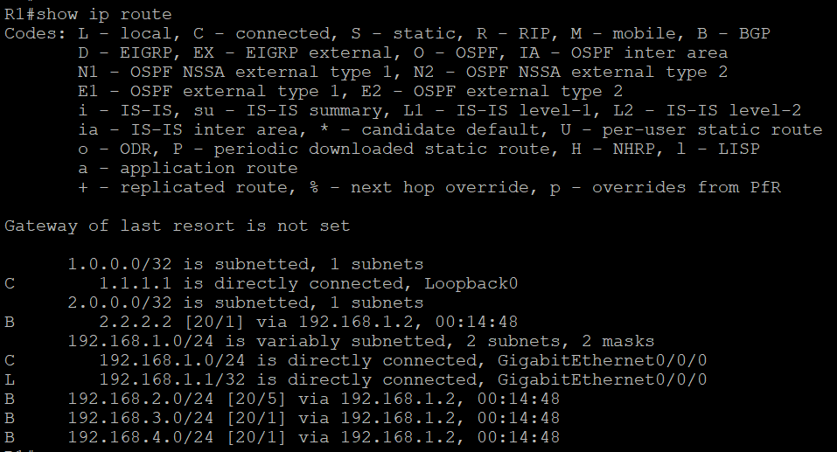

**Router 1 IP BGP:**

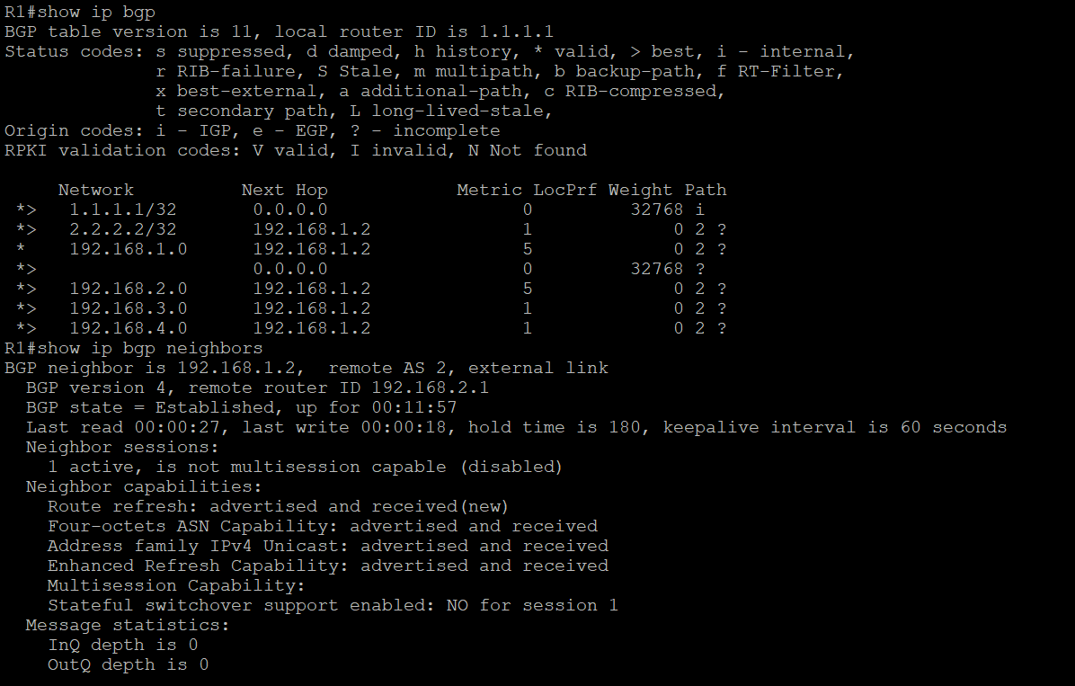

**Router 2 IP Route:**

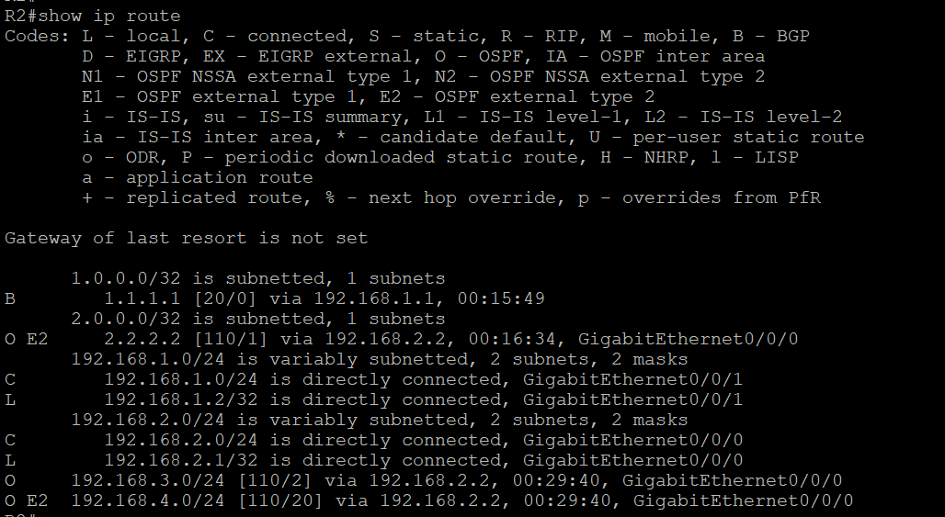

**Router 2 IP BGP:**

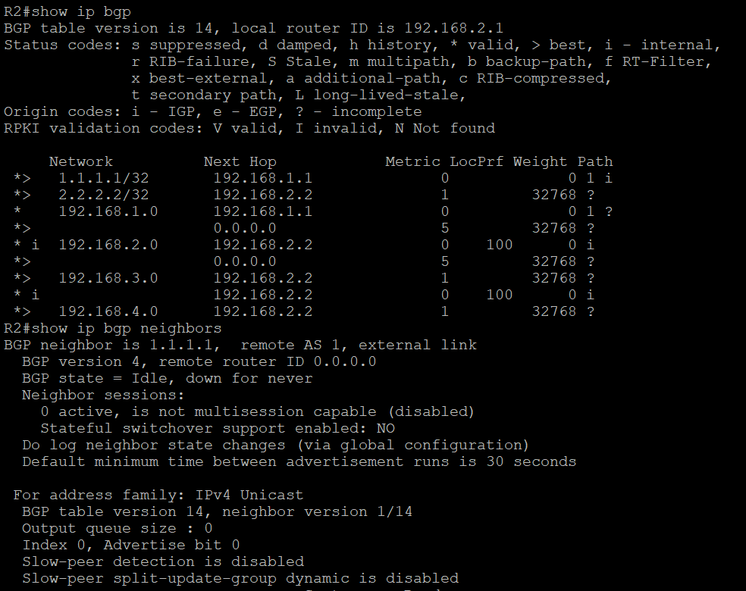

**Router 3 IP Route:**

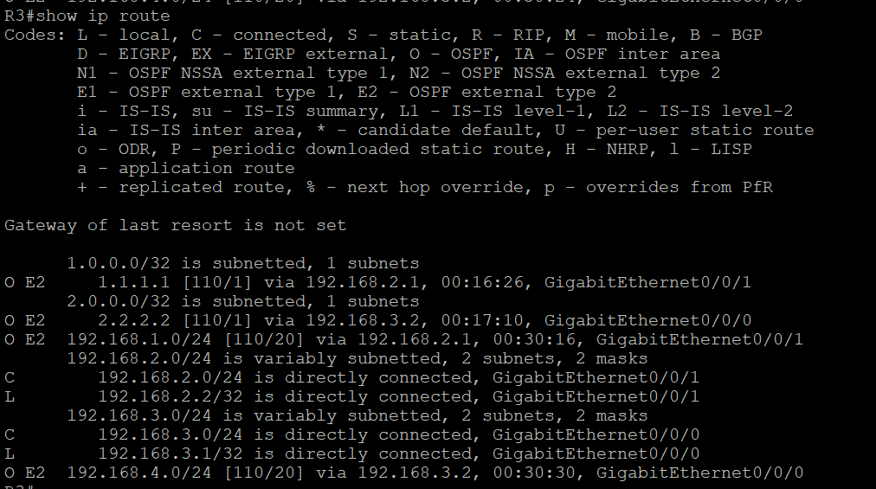

**Router 3 IP BGP:**

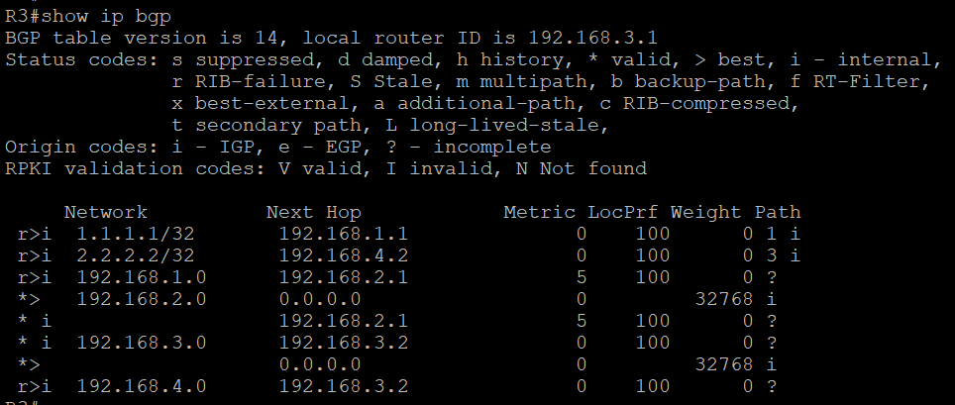

**Router 4 IP Route:**

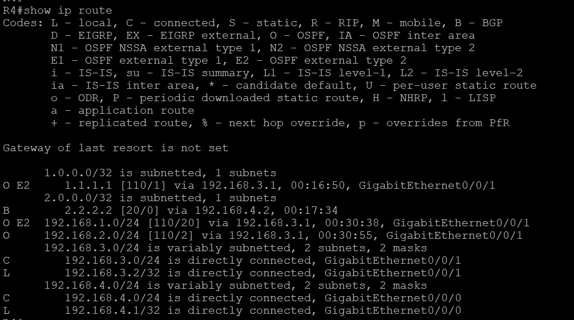

**Router 4 IP BGP:**

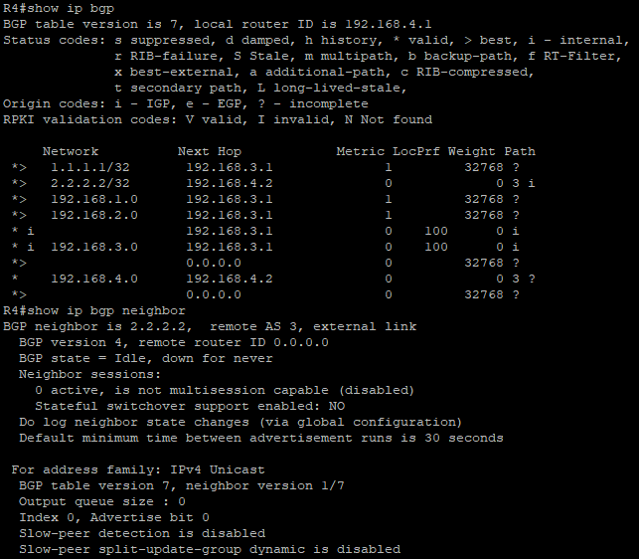

**Router 5 IP Route:**

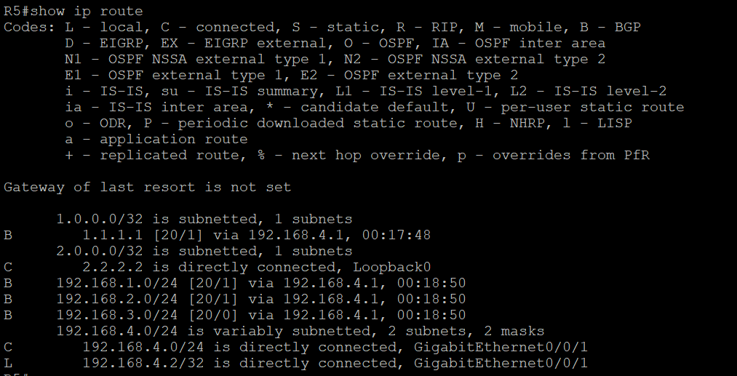

**Router 5 IP BGP:**

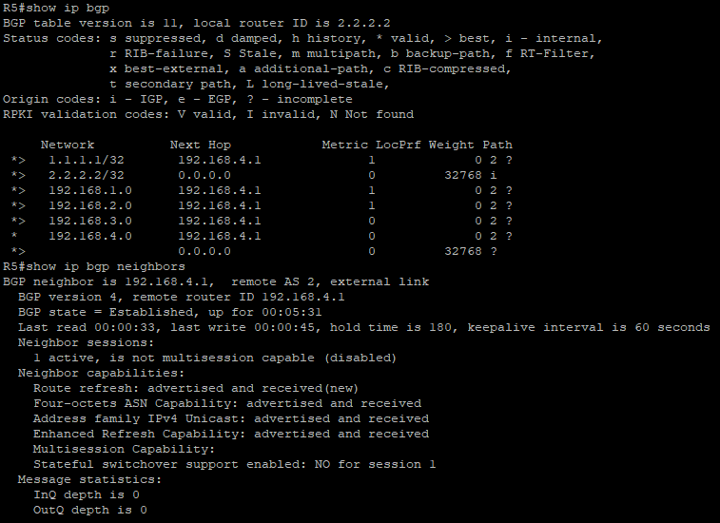

**Router 1 ping to Loopback 2.2.2.2:**

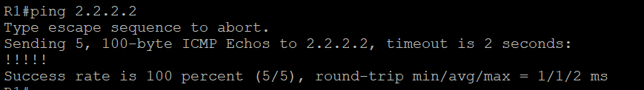

**Router 5 ping to Loopback 1.1.1.1:**

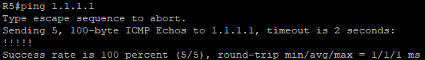

**Problems:**

The main problem that we faced was that we were only able to get connection within the iBGP autonomous system and couldn’t receive IPv4 routes from the edge routers configured with eBGP. Through research, we found that OSPF External Routes (E2) are advertised into OSPF Autonomous System with a certain cost and isn’t changed. These routes are learned through redistribution and the router performing redistribution is the ASBR (Autonomous System Border Router. Therefore, all OSPF routes learned through redistribution are type E2. In order to redistribute OSPF routes into BGP, we learned to enter in “**redistribute osp1 match external 2.**”

The other problem that we faced is that we had everything correctly set up but simply forgot to redistribute BGP, so our BGP wasn’t working. What this does is that it specifies routes from a certain protocol to be imported into BGP.

**Conclusion:**

In conclusion, this lab taught us once again the importance of Border Gateway Protocol and most specifically its two types, Internal BGP and External BGP. Internal BGP is crucial for facilitating communication within a single autonomous system and External BGP is essential for the exchanging of routing information between different autonomous systems on the internet. In the greater context of our world, these routing protocols are necessary for global internet connectivity between different autonomous systems.

**Teacher Signoff:**

